**Exercise 2: Verifying Interactions**

1.Main class:

public class Rectangle {

private MathService service;

public Rectangle(MathService service) {

this.service = service;

}

public int computeArea(int length, int width) {

return service.multiply(length, width);

}

}

2. External API

public class MathService {

public int multiply(int a, int b) {

return a * b;

}

}

3.pom.xml file

<project xmlns="http://maven.apache.org/POM/4.0.0" xmlns:xsi="http://www.w3.org/2001/XMLSchema-instance" xsi:schemaLocation="http://maven.apache.org/POM/4.0.0 https://maven.apache.org/xsd/maven-4.0.0.xsd">

<modelVersion>4.0.0</modelVersion>

<groupId>mockito</groupId>

<artifactId>MockitoOperations</artifactId>

<version>0.0.1-SNAPSHOT</version>

<dependencies>

<!-- Mockito Core (use with JUnit 5) -->

<dependency>

<groupId>org.mockito</groupId>

<artifactId>mockito-core</artifactId>

<version>5.11.0</version> <!-- or latest version -->

<scope>test</scope>

</dependency>

<!-- JUnit Jupiter Engine to run tests -->

<dependency>

<groupId>org.junit.jupiter</groupId>

<artifactId>junit-jupiter-engine</artifactId>

<version>5.12.0</version>

<scope>test</scope>

</dependency>

</dependencies>

</project>

4.unit test file for mocking and stubbing

**import** **static** org.junit.jupiter.api.Assertions.*;

**import** **static** org.mockito.Mockito.*;

**import** org.junit.jupiter.api.BeforeAll;

**import** org.junit.jupiter.api.Test;

**class** RectangleTest {

**private** **static** Rectangle *rect*;

**private** **static** MathService *service*;

@BeforeAll

**static** **void** setup() {

*service* = *mock*(MathService.**class**);

*rect* = **new** Rectangle(*service*);

}

@Test

**void** testComputeArea() {

*when*(*service*.multiply(6, 7)).thenReturn(42);

*assertEquals*(42, *rect*.computeArea(6, 7));

verify(service).multiply(6,7);

//verify(service).multiply(7,6) 🡪fails because no call happened with multiply(7,6)

}

}

Output:

1.

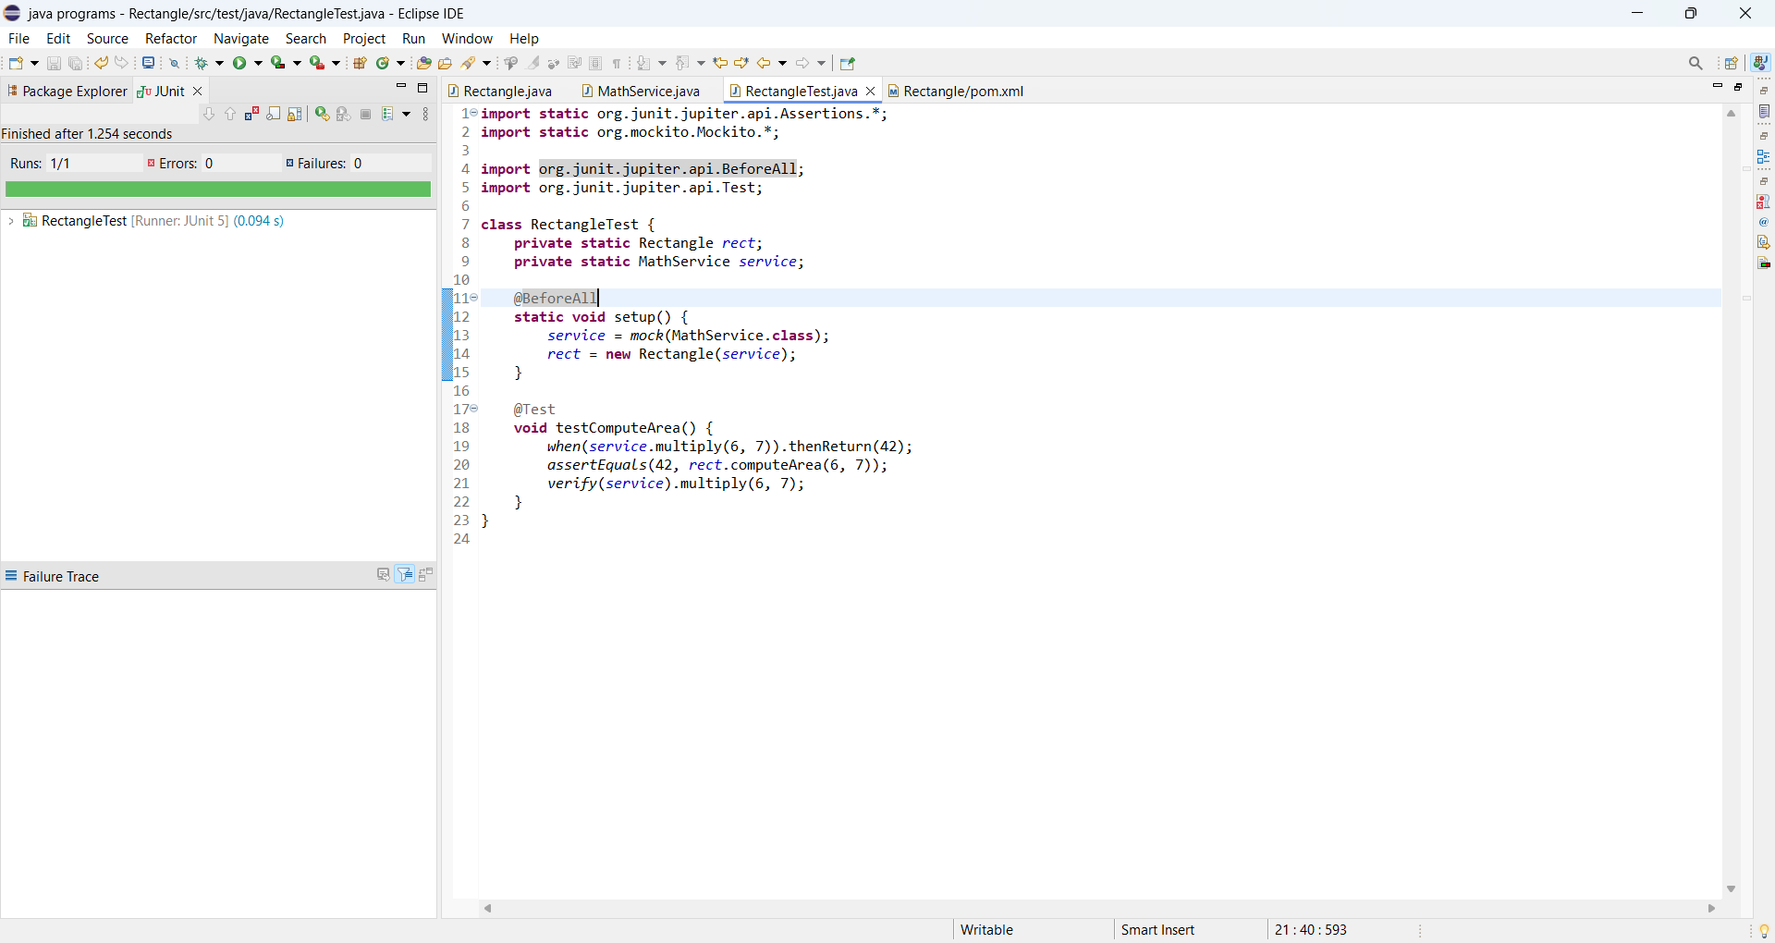

2.

